Meadow Vale Primary School – Year 1
Topic: All about me | Phase: KS1
Vocabulary
Compass | A compass is a tool for finding a direction.
Human feature | These come from human ideas and actions. They include bridges houses,and parks.
Map | Its basic purpose is to show where things are.
Physical feature | These features are found in nature, like mountains, rivers, lakes, and valleys.
Season | The seasons are four different times during the year with different types of weather.
Self portrait | A painting or drawing that the artist makes of themselves.
Weather | What it is like outside in the air.

3

Objectives for the topic:

2

1

Science – Season of Autumn
What should I already know?
- The 4 seasons: spring, summer, autumn, winter.
- What a map is.
- That they come to Meadow Vale school.

- observe changes across the four seasons
- observe and describe weather associated with the seasons and how day length varies.

Art – Self-portrait
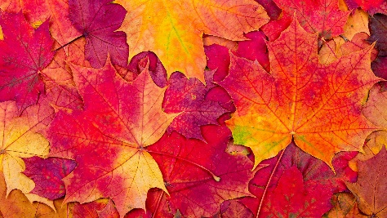
Autumn leaves

- to develop a wide range of art and design techniques in using colour, pattern, texture, line, shape, form and space

- to use a range of materials creatively to design and make products


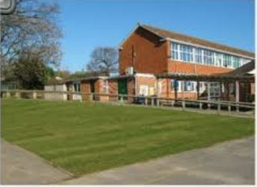
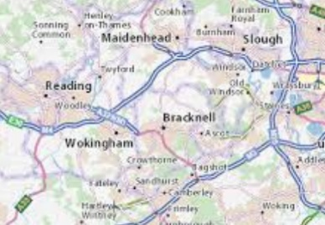
East
West
South
North
Physical feature
Human feature
- use simple compass directions (North, South, East and West) and locational and directional language [for example, near and far; left and right], to describe the location of features and routes on a map

- use aerial photographs and plan perspectives to recognise landmarks and basic human and physical features; devise a simple map.

- use simple fieldwork and observational skills to study the geography of their school

Geography

