Meadow Vale Primary School – Year 1
Science: Everyday Materials | Phase: KS1
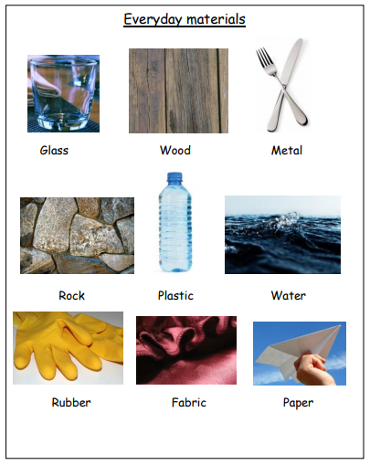
3

1

Scientific Vocabulary
Absorbent | A material that can soak up liquid easily.
Transparent | A material you can see through such as glass.
Opaque | A material you cannot see through at all.
Natural | Materials that exist in nature and are not made by people.
Man-Made | Materials created by people.
Waterproof | Does not let water pass through.
Elastic | A rubber material that stretches when pulled and returns to its original size and shape when you let it go.
Hard | Solid, firm and rigid; not easily broken, bent or pierced.
Soft | Easy to bend or to shape.
Shiny | Having a smooth glossy surface
Dull | Not shiny
Rough | Having an uneven surface. Not smooth.
Smooth | Having an even or regular surface
Bendy | Capable of bending; soft and flexible
Not bendy | Not soft and flexible
Waterproof | Something that keeps water out.
Not waterproof | Something that lets water in.

What should I already know?
- Objects feel and look different based on the materials they are made from.
- We can use different materials when painting and making art.

End of unit objectives:

2

Distinguish between an object and the material from which it is made.

Identify and name a variety of everyday materials, including wood, plastic, glass, metal, water, and rock.

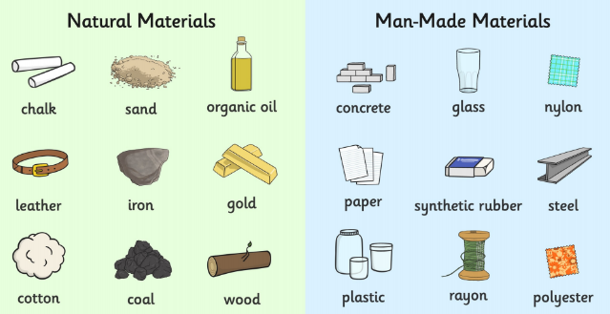
Links to other curriculum areas:
- D&T – making castles out of materials.
4

Compare and group together a variety of everyday materials on the basis of their simple physical properties.

Describe the simple physical properties of a variety of everyday materials

