Meadow Vale Primary School – Year 1
Science: Seasonal change | Phase: KS1
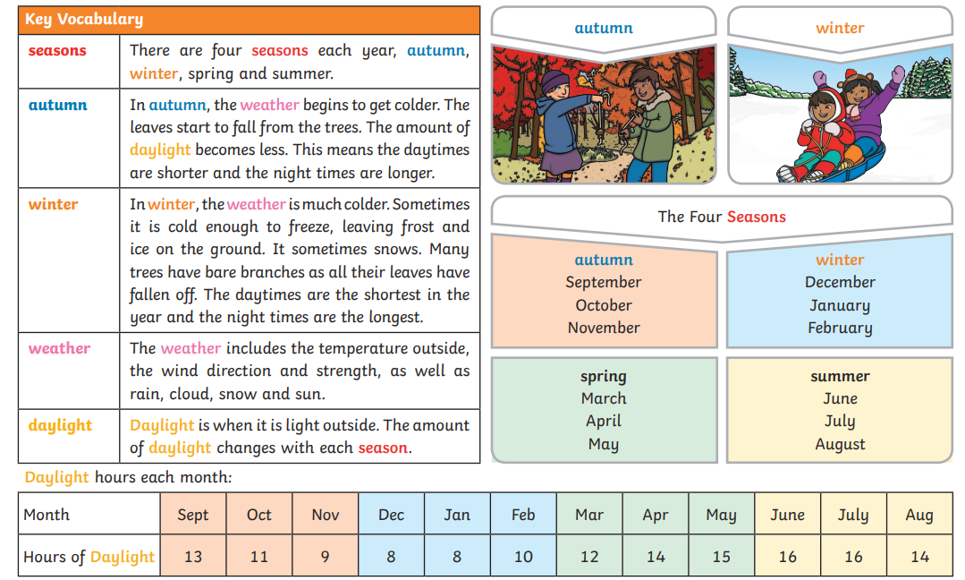
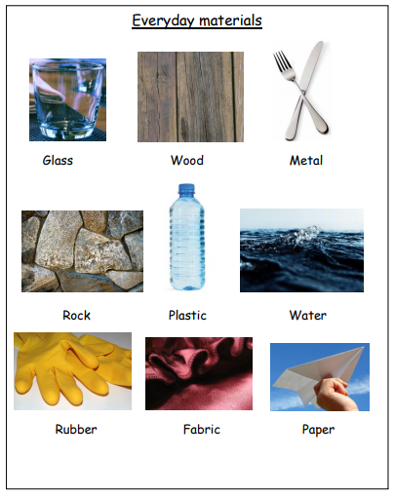
Scientific Vocabulary
Absorbent | A material that can soak up liquid easily.
Transparent | A material you can see through such as glass.
Opaque | A material you cannot see through at all.
Natural | Materials that exist in nature and are not made by people.
Man-Made | Materials created by people.
Waterproof | Does not let water pass through.
Elastic | A rubber material that stretches when pulled and returns to its original size and shape when you let it go.

What should I already know?
- Objects feel and look different based on the materials they are made from.
- We can use different materials when painting and making art.

End of unit objectives:
- I can distinguish between an object and the material from which it is made.
- I can identify and name a variety of everyday materials, including wood, plastic, glass, metal, water, and rock.
- I can describe the simple physical properties of a variety of everyday materials
- I can compare and group together a variety of everyday materials on the basis of their simple physical properties.

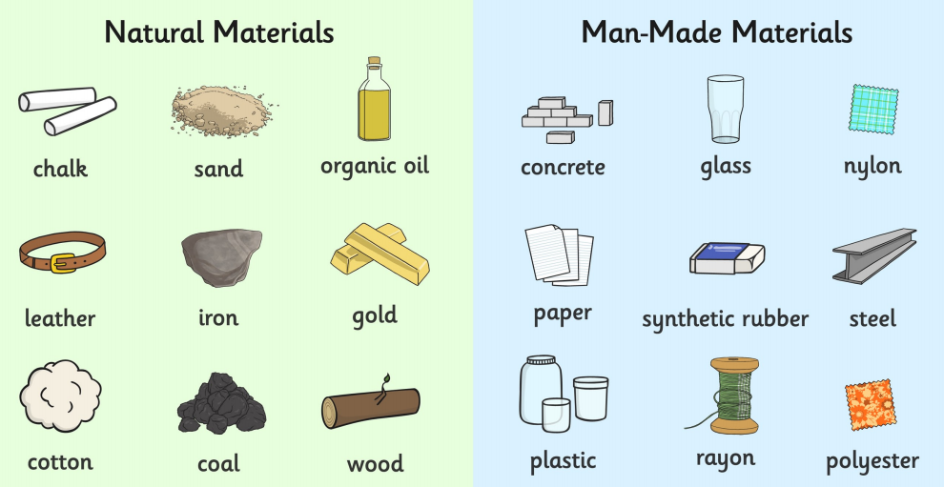
Key words:
hard/soft
stretchy/stiff
shiny/dull
rough/smooth
bendy/not bendy
waterproof/not waterproof

