Meadow Vale Primary School – Year 1
Topic: Plants | Phase: KS1
3

2

What should I already know?
The difference between a plant and a tree. Names of some plants and trees.

1

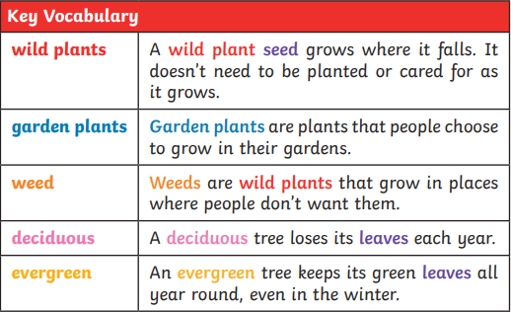
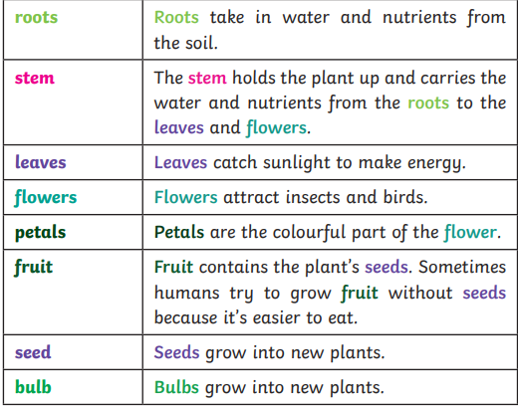

Objectives for the topic:

identify and name a variety of common wild and garden plants, including deciduous and evergreen trees

3

identify and describe the basic structure of a variety of common flowering plants, including trees
Parts of a plant



