Meadow Vale Primary School – Year 1
Making a…SPLASH! | Phase: KS1
3

1

Key Vocabulary
City | A large town.
Coast | The part of land near the sea.
Country | A large area of land controlled by a government.
Island | A piece of land surrounded by the sea.
Sea | Salt water covering most of the Earth’s surface.
Bay | A place where the coast bends inwards and the sea fills the space.
Cliff | A steep rock face close to the edge of the sea.
Harbour | A place by the seaside where boats can stay safely in the water.
Pier | A structure for people to walk along that is built out into the sea.
Dunes | Hills or mounds of sand held together by plants.

What should I already know?
- I know the four countries that make up the UK.
- The children should know what a beach is and some of its features.

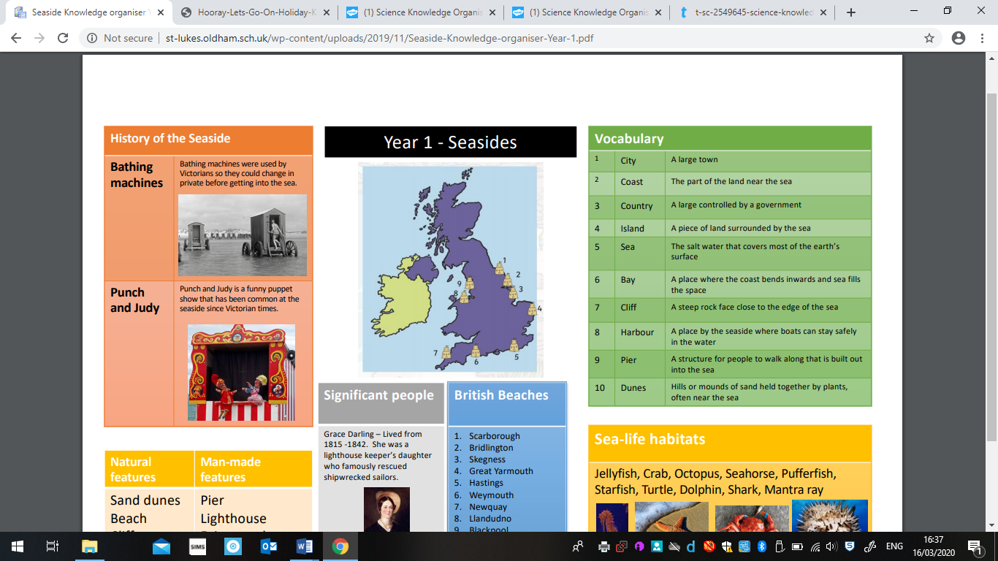

2

End of unit objectives:

I will know the different between human and physical features.

I can use basic geographical vocabulary.

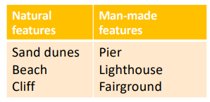
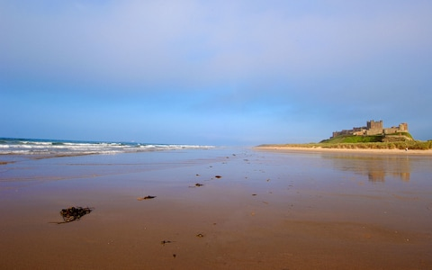
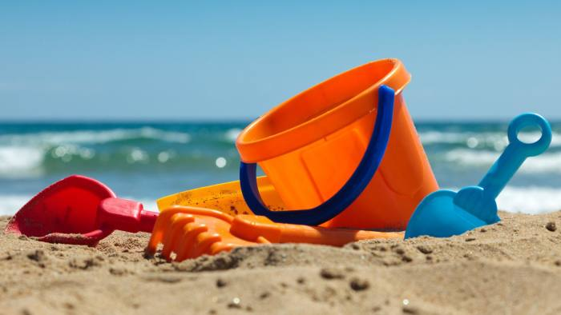
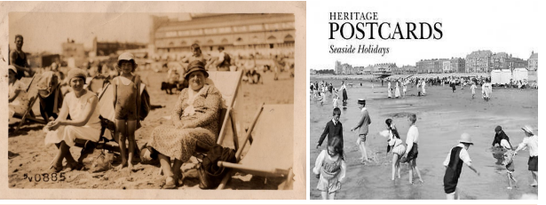

I can explain the differences between the seaside now and the past.

I can name, locate and identify the seas surrounding seas.

