Meadow Vale Primary School
Topic: Animals including humans | Subject(s): Science | Year: 2
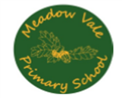
What should I already know?
- Name a variety of common animals including, fish, amphibians, reptiles, birds and mammals.
- Name a variety of common animals that are carnivores, herbivores and omnivores
- Describe and compare the structure of a variety of common animals (fish, amphibians, reptiles, birds and mammals including pets)
- Name, draw and label the basic parts of the human body and say which part of the body is associated with each sense.
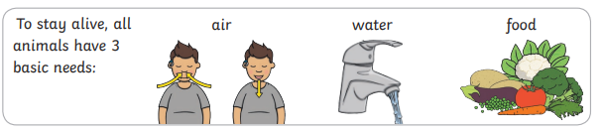
General vocabulary
adult | A fully grown up animal or plant.
Habitat | A place where something lives.
develop | To grow and become stronger.
dehydrate | To lose water
Life-cycle | The changes living things go through to become an adult.
diet | The food and water that an animal needs.
Offspring | The child of an animal.
germs | Bugs that cause disease and illness.
Reproduce | When living things make a new living thing of the same kind.
Hygiene | How clean something is (To stay healthy).
young | Offspring that has not reached adulthood.
nutrition | Food needed to live and stay healthy.
Live young | Offspring that has not hatched from an egg.
Pulse | The beating of the heart that can felt in the neck or wrist.

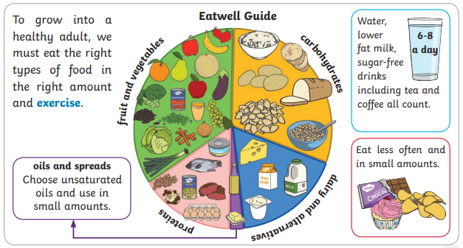

Links to other curriculum areas:
We will find out about a range of different Australian animals and their offspring linked to our topic ‘Australia.’
We will find out about the importance of exercise, hygiene and eating a healthy balanced diet linked to our PSHE topic ‘Healthy me.’

What will we be learning about?
- Notice that animals, including humans, have offspring which grow into adults.
- Find out about and describe the basic needs of animals, including humans, for survival (water, food and air).
- Describe the importance for humans of exercise, eating the right amounts of different types of food, and hygiene.

